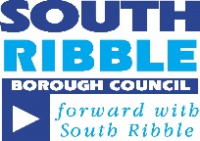

ARE YOU HAVING DIFFICULTY IN PAYING THE SHORTFALL IN YOUR COUNCIL TAX?
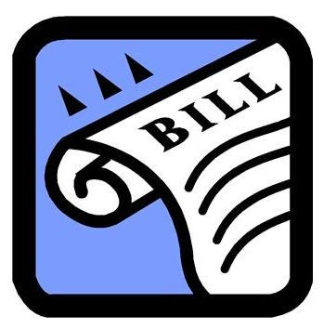

DO YOU NEED SOME EXTRA HELP WITH YOUR COUNCIL TAX BILL TO STOP YOU GETTING BEHIND WITH YOUR PAYMENTS?
If so a discretionary Local Scheme payment may help. They can be awarded as a top up to pay the difference between your Council Tax Support and your council tax charge, if you have a shortfall. They are to help you financially for a period of time to stop you getting behind with your payments, for example while you look for work.
Please apply as soon as possible if you need help.
Decisions are made based on your income and expenditure and personal circumstances. If you would like to apply please contact the Benefits Section on 01772 625518 or email benefits@southribble.gov.uk and request an application form. As a Council we are keen to support you to avoid getting into difficulties with Council Tax, Universal Credit and we are here to help. This reflects our desire to focus on prevention and the health and wellbeing of our residents.

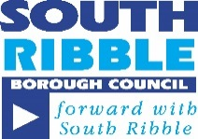
ARE YOU HAVING DIFFICULTY IN PAYING THE SHORTFALL IN YOUR RENT?
DO YOU WANT TO MOVE BUT CAN’T AFFORD REMOVAL COSTS, DEPOSITS ETC?
If so a Discretionary Housing Payment may help. They can be awarded as a top up to pay the difference between your Housing Benefit award or Housing Costs within Universal Credit, and your rent, if you have a shortfall. They are to help you financially for a period of time, for example while you look for work, or find a smaller or cheaper property
OR
If you are in receipt of Housing Benefit or Housing Costs within Universal Credit at your current address, they can help you to move to a smaller or more affordable property by helping towards moving costs such as first month’s rent, deposit, removal van etc
Decisions are made based on your income and expenditure and personal circumstances. If you would like to apply please contact the Benefits Section on 01772 625518 or email benefits@southribble.gov.uk and request an application form.

